**FAST**

**National University of Computer and Emerging Sciences**



**Web Programming**

**Lab #4**

**Submitted by:**

**Rimsha Sarfraz(21F-9244)**

**BSCS_6E**

**Submitted to: Mam Sumaira Mustafa**

**Dated: 17th Feb ,2024**

Task 1:

**Code:**

<!DOCTYPE html>

<html>

<head>

<title>Bootstrap</title>

<h1>Bootstrap Boxes are as follow:</h1>

<link rel="stylesheet" href="https://stackpath.bootstrapcdn.com/bootstrap/4.5.2/css/bootstrap.min.css">

</head>

<body>

<div class="container">

<div class="row">

<div class="col">

<div class="alert alert-primary" role="alert">

Primary alert with <a href="https://www.w3schools.com/bootstrap/bootstrap_ver.asp" class="alert-link">link</a>. Click it for more info.

</div>

</div>

<div class="col">

<div class="alert alert-secondary" role="alert">

Secondary alert with <a href="https://www.w3schools.com/bootstrap/bootstrap_ver.asp" class="alert-link">link</a>. Click it for more info.

</div>

</div>

<div class="col">

<div class="alert alert-success" role="alert">

Success alert with <a href="https://www.w3schools.com/bootstrap/bootstrap_ver.asp" class="alert-link">link</a>. Click it for more info.

</div>

</div>

</div>

<div class="row">

<div class="col">

<div class="alert alert-danger" role="alert">

Danger alert with <a href="https://www.w3schools.com/bootstrap/bootstrap_ver.asp" class="alert-link">link</a>. Click it for more info.

</div>

</div>

<div class="col">

<div class="alert alert-warning" role="alert">

Warning alert with <a href="https://www.w3schools.com/bootstrap/bootstrap_ver.asp" class="alert-link">link</a>. Click it for more info.

</div>

</div>

<div class="col">

<div class="alert alert-info" role="alert">

Info alert with <a href="https://www.w3schools.com/bootstrap/bootstrap_ver.asp" class="alert-link">link</a>. Click it for more info.

</div>

</div>

</div>

</div>

</body>

</html>

**Output:**

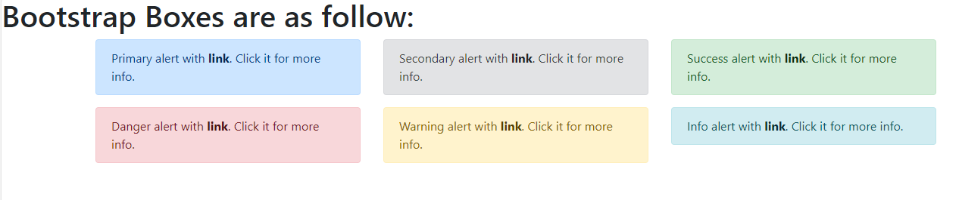

Task 2:

**Code:**

<!DOCTYPE html>

<html>

<head>

<title>Buttons</title>

<link rel="stylesheet" href="https://stackpath.bootstrapcdn.com/bootstrap/4.5.2/css/bootstrap.min.css">

</head>

<body>

<div class="container">

<h2>Buttons</h2>

<button type="button" class="btn btn-primary" onclick="displayMessage('Primary Task is completed!')">Primary</button>

<button type="button" class="btn btn-secondary" onclick="displayMessage('Secondary Task is completed!')">Secondary</button>

<button type="button" class="btn btn-success" onclick="displayMessage('Login Successfully!')">Success</button>

<button type="button" class="btn btn-danger" onclick="displayMessage('Danger !Dont press That button again!')">Danger</button>

<button type="button" class="btn btn-warning" onclick="displayMessage('Information recieved!')">Information</button>

<button type="button" class="btn btn-info" onclick="displayMessage('Warning!There is something Wrong!')">Warning</button>

</div>

<script>

function displayMessage(message) {

alert(message);

}

</script>

</body>

</html>

**Output:**

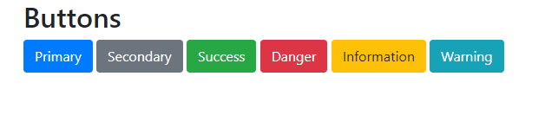

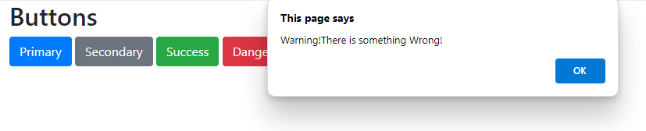

Task 3:

**Code:**

<!DOCTYPE html>

<html>

<head>

<title>Rimsha's Calculator</title>

</head>

<body>

<h2>Rimsha's Calculator</h2>

<form id="calculatorForm">

<label for="num1">Enter First Number:</label>

<input type="text" id="num1" name="num1"><br><br>

<label for="num2">Enter Second Number:</label>

<input type="text" id="num2" name="num2"><br><br>

<button type="button" onclick="calculate('add')">Add</button>

<button type="button" onclick="calculate('subtract')">Subtract</button>

<button type="button" onclick="calculate('multiply')">Multiply</button>

<button type="button" onclick="calculate('divide')">Divide</button><br><br>

<label for="result">Solution:</label>

<input type="text" id="result" name="result" readonly>

</form>

<script>

function calculate(operation) {

var num1 = parseFloat(document.getElementById('num1').value);

var num2 = parseFloat(document.getElementById('num2').value);

var result = 0;

switch (operation) {

case 'add':

result = num1 + num2;

break;

case 'subtract':

result = num1 - num2;

break;

case 'multiply':

result = num1 * num2;

break;

case 'divide':

result = num1 / num2;

break;

default:

result = "Invalid operation";

}

document.getElementById('result').value = result;

}

</script>

</body>

</html>

**Output:**

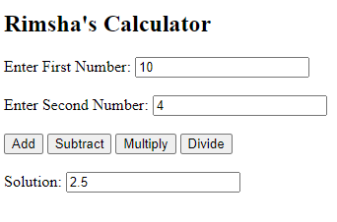

Task 4:

**Code:**

<!DOCTYPE html>

<html>

<head>

<title>Month Days Calculator</title>

</head>

<body>

<h2>Month to Days</h2>

<form id="monthForm">

<label for="month">Kindly enter the name of the month in short_form(e.g., Jan, Feb, Mar):</label>

<input type="text" id="month" name="month" placeholder="e.g., Jan"><br><br>

<button type="button" onclick="calculateDays()">Calculate</button><br><br>

<label id="result"></label>

</form>

<script>

function calculateDays() {

var monthInput = document.getElementById('month').value.toLowerCase();

var daysInMonth = 0;

var resultElement = document.getElementById('result');

switch (monthInput) {

case 'jan':

case 'mar':

case 'may':

case 'jul':

case 'aug':

case 'oct':

case 'dec':

daysInMonth = 31;

break;

case 'apr':

case 'jun':

case 'sep':

case 'nov':

daysInMonth = 30;

break;

case 'feb':

daysInMonth = 28;

break;

default:

resultElement.innerHTML = "Invalid month name";

return;

}

resultElement.innerHTML = `Total number of days in <span style="color:red">${monthInput.toUpperCase()}</span>: <span style="color:red">${daysInMonth}</span>`;

}

</script>

</body>

</html>

**Output:**

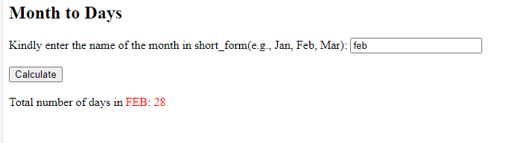

Task 5:

**Code:**

<!DOCTYPE html>

<html>

<head>

<title>Maths Table</title>

</head>

<body>

<script>

var num = parseInt(prompt("Kindly Enter a number:"));

if (!isNaN(num)) {

document.write(`<h2>Table of ${num}: </h2>`);

document.write("<ul>");

for (var i = 1; i <= 10; i++) {

document.write(`<li>${num} x ${i} = ${num * i}</li>`);

}

document.write("</ul>");

} else {

document.write("<p>Invalid input...Please enter a valid number.</p>");

}

</script>

</body>

</html>

**Output:**

